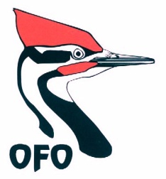
OFO Annual Convention
Annual General Meeting
23 September 2017
OFO Certificates of Appreciation

Each year, OFO recognizes individuals and organizations for their contribution to the birds and birding community of Ontario. Again this year we have some very worthy recipients, but the list could be even longer! Please, whenever you are aware of a member of the public providing access to a rare bird or in some other way assisting birders, send in your nomination through the OFO website.

The recipients of the 2016-2017 awards are:

- Anouk Hoedeman, for co-founding Safe Wings Ottawa in 2013 and for her tireless efforts to reduce bird mortality from window collisions through research, rescue, and education.
- Brian Ratcliff, for keeping track of rare bird records and assisting the OBRC for the northwestern Ontario region.
- Mark Peck, for his many years in assisting the OBRC as ROM liaison and for providing expert opinion on records reviewed by the OBRC.
- Margaret Bain, for compiling and organizing the Ontario section of North American Birds over the past decade.
- Heidi Staniforth and Kelly Moore, operators of the Tern In B&B, for hosting and welcoming birders wishing to view a White-winged Dove at their property in May 2017.
- Mike Malone and Joan Walker of Pelee Wings and Mike Wales, for generously welcoming and allowing access to birders wishing to view the Magnificent Frigatebird in July 2017, near Point Pelee National Park.
- Lisa Bildy, for her extensive contribution to the OFO Young Birders camp.
- Jeff and Angela Skevington, for volunteering as camp counsellors during the OFO Young Birders camp.
- Don Kennedy, for his outstanding volunteerism and coordination of efforts to assist the nesting Piping Plovers at Sauble Beach over the last 11 years.

